CNL ASSIGNMENT – 2 31139

WRITEUP:

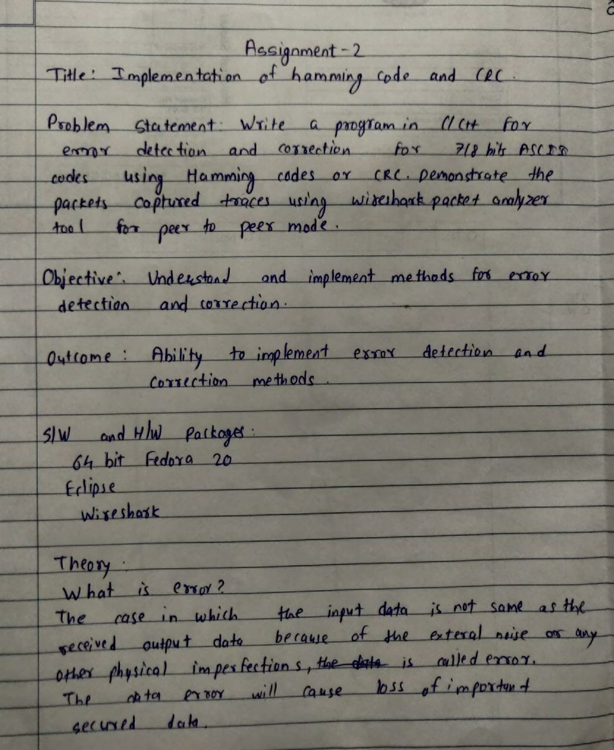

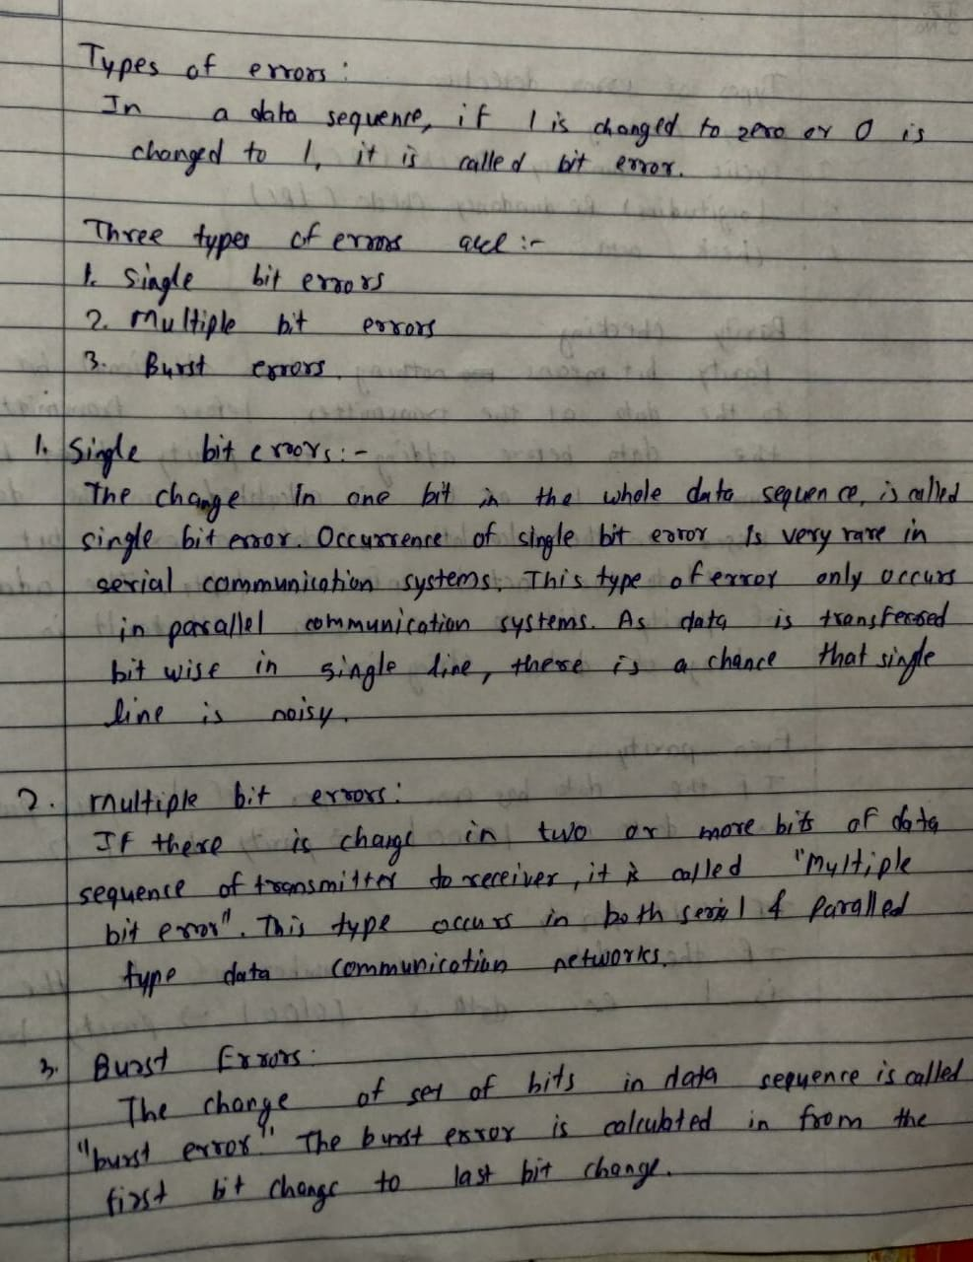

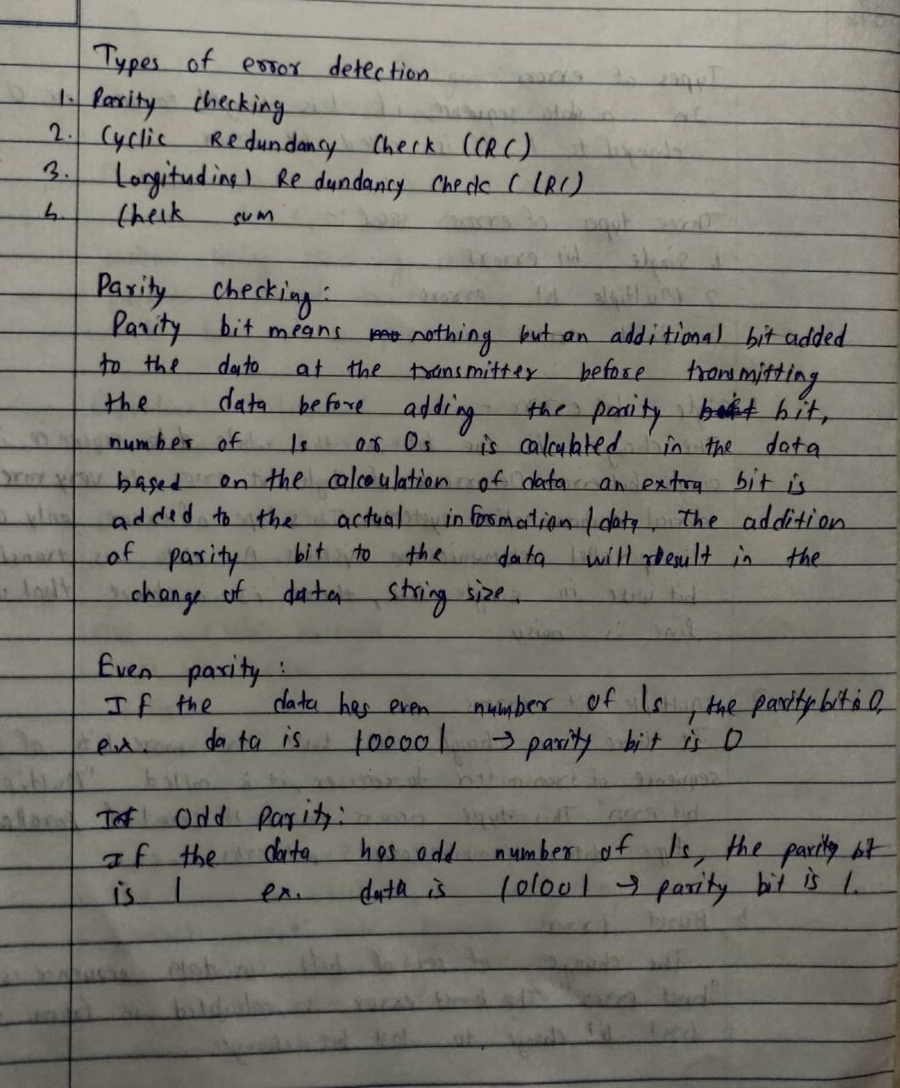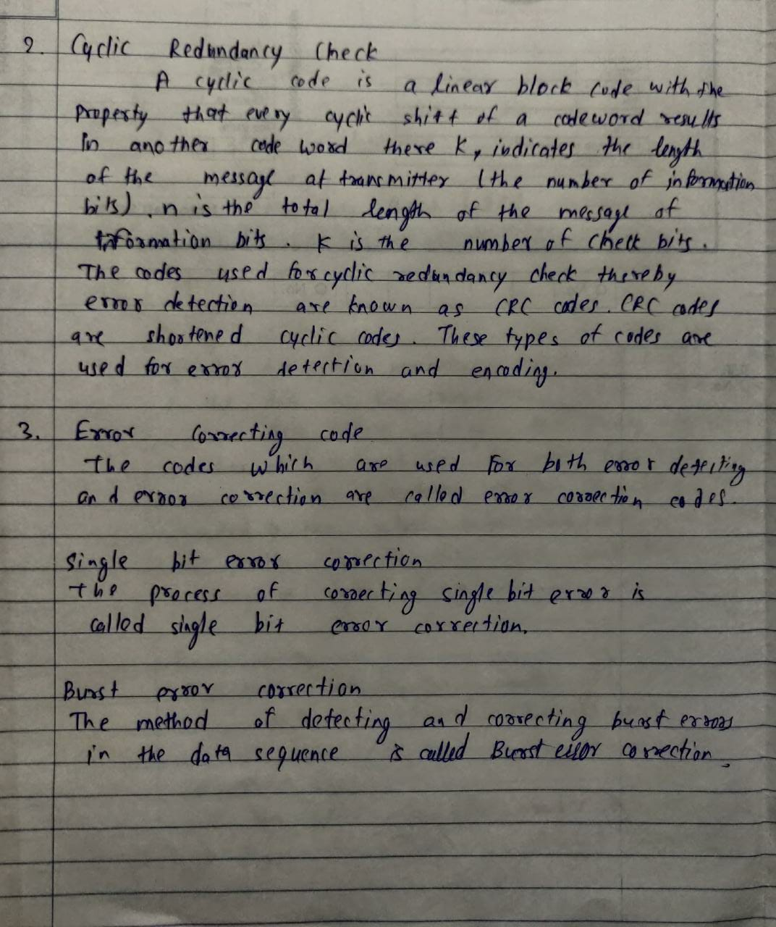

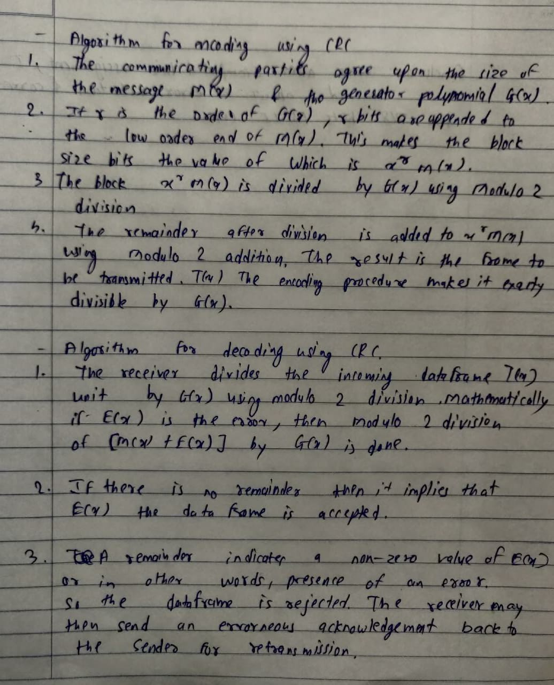

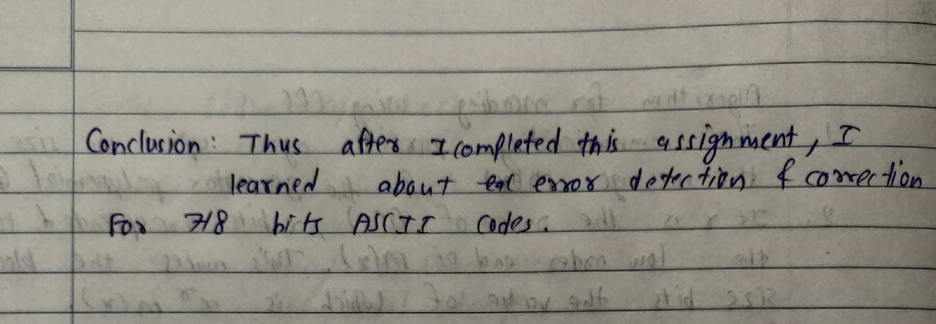

SAMPLE CODE:

#include<iostream>

using namespace std;

void division(int temp[], int gen[], int n, int r)

{

for (int i = 0; i < n; i++)

{

if (gen[0] == temp[i])

{

for (int j = 0, k = i; j < r + 1; j++, k++)

{

if (!(temp[k] ^ gen[j]))

temp[k] = 0;

else

temp[k] = 1;

}

}

}

}

int main()

{

int n, r, message[50], gen[50], temp[50];

cout << "-------SENDER-------" << endl;

cout << "Enter the number of message bits : ";

cin >> n;

cout << "Enter the number of generator bits : ";

cin >> r;

cout << "Enter the message : ";

for (int i = 0; i < n; i++)

cin >> message[i];

cout << "Enter the generator : ";

for (int i = 0; i < r; i++)

cin >> gen[i];

r--;

for (int i = 0; i < r; i++)

message[n + i] = 0;

for (int i = 0; i < n + r; i++)

temp[i] = message[i];

division(temp, gen, n, r);

cout << "CRC : ";

for (int i = 0; i < r; i++)

{

cout << temp[n + i] << " ";

message[n + i] = temp[n + i];

}

cout << endl << "Message Transmitted : ";

for (int i = 0; i < n + r; i++)

cout << message[i] << " ";

cout << endl << endl << "------RECEIVER------ " << endl;

cout << "Enter the received message : ";

for (int i = 0; i < n + r; i++)

cin >> message[i];

for (int i = 0; i < n + r; i++)

temp[i] = message[i];

division(temp, gen, n, r);

for (int i = 0; i < r; i++)

{

if (temp[n + i])

{

cout << "Error detected in received message.";

return 0;

}

}

cout << "No error in received Message.\nReceived Message : ";

for (int i = 0; i < n; i++)

cout << message[i] << " ";

return 0;

}

OUTPUT:

